Assignment 4

Question 1

AIM:
To make a program using concept of Stacks.

CODE:
"""
Assignment 4 Question 1 done by Vansh Aggarwal
Date: 20/7/24

"""

def add():
lst=[]
nam=input("Enter magazine name: ")
typ=input("Enter type: ")
fre=input("Enter frequency: ")
pri=int(input("Enter price: "))
lst=[nam,typ,fre,pri]
mag.append(lst)

def pop():
if mag==[]:
print("Stack empty")
else:
let=len(mag)-1
a=mag.pop(let)
return a

def peek():
if mag==[]:
print("Stack empty")
else:
lent=len(mag)-1
a=mag[lent]
return a

def display():
if mag==[]:
print("Stack empty")
else:
print(mag[::-1])

mag=[]
while True:
i=int(input('''
1. Push
2. Pop
3. Peek
4. Display
5. Exit: '''))

if i==1:
add()
elif i==2:
print(pop())
elif i==3:
print(peek())
elif i==4:
display()
elif i==5:
break
else:
print("Wrong option")

SAMPLE OUTPUT:
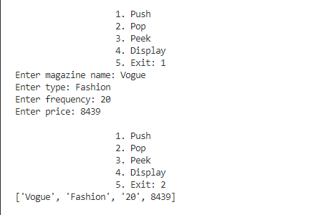
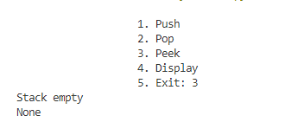
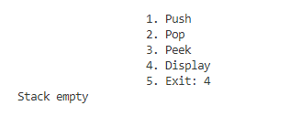

Question 2:

AIM:
To use concept of Stack to build a program that displays required data.
CODE:

"""
Assignment 4 Question 3 done by Vansh Aggarwal
Date: 20/7/24

"""

def add():
dic={}
regno=input("REGNO: ")
marks=float(input("MARKS: "))
dic[regno]=marks
m_list.append(dic)

def seats():
if len(s_list)>7:
print("overflow")
else:
ref=[]
for i in s_list:
for key in i:
ref.append(key)

for i in m_list:
for key in i:
if float(i[key])>98.5 and key not in ref:
s_list.append(i)

def selection():
if s_list==[]:
print("Empty")
else:
print(s_list[::-1])

def search():
ref=[]

for i in s_list:
for key in i:
ref.append(key)

if s_list==[]:
print("Empty")

cand=input("Enter regno: ")

if cand not in ref:
print("Candidate absent")

else:
count=0
for i in s_list[::-1]:
for keys in i:
if cand!=i[keys]:
count+=1
else:
break

print("Position of candidate is", count)

def pop():
if s_list==[]:
print("Empty")
else:
lent=len(s_list)-1
a=s_list.pop(lent)
return a

m_list=[]
s_list=[]

while True:
a=int(input('''
1. Push
2. Transfer
3. Show selection list
4. Search for candidate result
5. Withdraw admission
6. Exit: '''))

if a==1:
add()
elif a==2:
seats()
elif a==3:
selection()
elif a==4:
search()
elif a==5:
pop()
elif a==6:
break
else:
print("Wrong option")

SAMPLE OUTPUT:
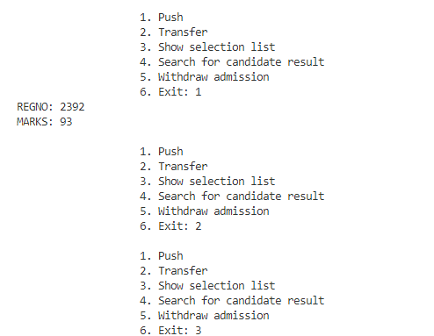

Question 3:

AIM:
Using Stacks in code.

CODE:
"""
Assignment 4 Question 2 done by Vansh Aggarwal
Date: 29/7/24

"""

import random

def inp():
while True:
a=input("Enter number (type 'exit' to finish)")
if a.lower()=="exit":
break
try:
b=int(a)
lst.append(b)
except ValueError:
print("Please enter a valid number")

def display():
print(lst)

def bubble():
order=input("Enter a for ascending and d for descending: ")
n=len(lst)
if order=="a":
for i in range(n):
for j in range(0, n-i-1):
if lst[j]>lst[j+1]:
lst[j], lst[j+1]=lst[j+1], lst[j]

elif order=="d":
for i in range(n):
for j in range(0, n-i-1):
if lst[j]<lst[j+1]:
lst[j], lst[j+1]=lst[j+1], lst[j]

else:
print("Incorrect option")

def insert():
order=input("Enter a for ascending and d for descending: ")
n=len(lst)
if order=="a":
for i in range(1, n):
key=lst[i]
j=i-1
while j>=0 and key<lst[j]:
lst[j+1]=lst[j]
j-=1
lst[j+1]=key

elif order=="d":
for i in range(1, n):
key=lst[i]
j=i-1
while j>=0 and key>lst[j]:
lst[j+1]=lst[j]
j-=1
lst[j+1]=key

else:
print("Option unavailable")

def shuffle():
n=len(lst)
for i in range(n):
a=random.randint(0, n-1)
lst[i], lst[a]=lst[a], lst[i]

lst=[]

while True:
a=int(input('''
1. Input
2. Display
3. Bubble Sort
4. Insertion Sort
5. Shuffle
6. Exit: '''))

if a==1:
inp()
elif a==2:
display()
elif a==3:
bubble()
elif a==4:
insert()
elif a==5:
shuffle()
elif a==6:
break
else:
print("Wrong option")

SAMPLE OUTPUT:
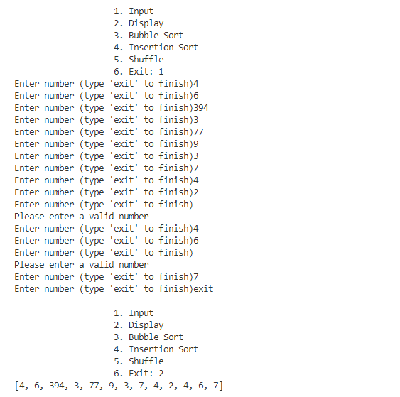
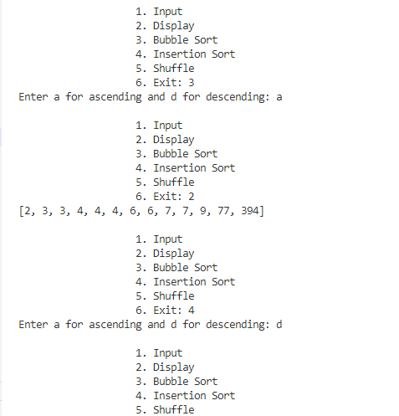
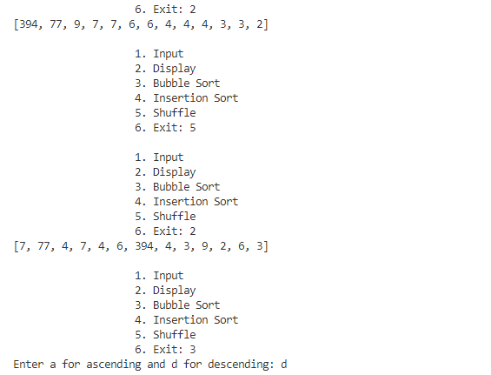
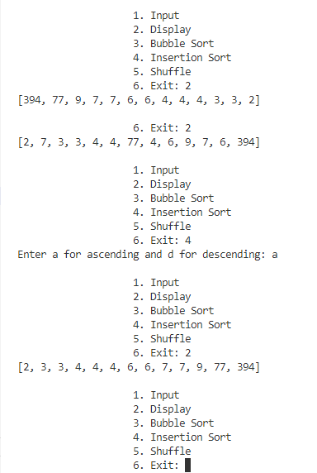

Question 4

AIM:
To make a program using concept of Stacks.

CODE:
"""
Assignment 4 Question 4 done by Vansh Aggarwal
Date: 30/7/24

"""

def create():
global ma
ma=[]
row=int(input("Enter number of rows: "))
col=int(input("Enter number of columns: "))
for i in range(row):
lst=[]
for j in range(col):
a=int(input(f"Enter value at ({i}, {j}): "))
lst.append(a)
ma.append(lst)

def display(matrix):
if not matrix:
print("Matrix is empty.")
else:
for row in matrix:
print(row)

def s_row():
if len(ma)<2:
print("Not enough rows to swap.")
return
ma[0],ma[-1]=ma[-1],ma[0]

def s_col():
if not ma:
print("Matrix is empty.")
return
num_rows=len(ma)
num_cols=len(ma[0])
if num_cols<2:
print("Not enough columns to swap.")
return
for i in range(num_rows):
ma[i][0],ma[i][-1]=ma[i][-1],ma[i][0]

def sum_mid():
if not ma:
print("Matrix is empty.")
return

total_sum=0
num_rows=len(ma)
num_cols=len(ma[0])

if num_rows%2==1:
mid_row_index=num_rows//2
mid_row_sum=sum(ma[mid_row_index])
print(f"Sum of middle row {mid_row_index} is {mid_row_sum}")
total_sum+=mid_row_sum
else:
print("No middle row in an even-row matrix.")

if num_cols%2==1:
mid_col_index=num_cols//2
mid_col_sum=0
for row in ma:
mid_col_sum+=row[mid_col_index]
print(f"Sum of middle column {mid_col_index} is {mid_col_sum}")
total_sum+=mid_col_sum
else:
print("No middle column in an even-column matrix.")

return total_sum

def sum_alt():
if not ma:
print("Matrix is empty.")
return
sum=0
for row in ma:
for j in range(0,len(row),2):
sum+=row[j]
print(f"Sum of alternate elements: {sum}")

def transp():
if not ma:
print("Matrix is empty.")
return
num_rows=len(ma)
num_cols=len(ma[0])

transposed=[]
for i in range(num_cols):
new_row=[]
for j in range(num_rows):
new_row.append(ma[j][i])
transposed.append(new_row)

print("Transpose of the matrix:")
display(transposed)

ma=[]

while True:
a=int(input('''
1. Create
2. Display
3. Swap First and Last Row
4. Swap First and Last Column
5. Sum Middle Row and Column
6. Sum Alternate Elements
7. Transpose Matrix
8. Exit: '''))
if a==1:
create()
elif a==2:
display(ma)
elif a==3:
s_row()
elif a==4:
s_col()
elif a==5:
sum_mid()
elif a==6:
sum_alt()
elif a==7:
transp()
elif a==8:
break
else:
print("Invalid option")

SAMPLE OUTPUT:

